Verification of all gates using UNIVERSAL GATES

Experiment no. 3 Date:
AIM:
To study and verify the all logic gates using UNIVERAL Gate NAND.

APPARATUS REQUIRED:
Logic gates (IC) trainer kit. Connecting patch chords or wires. IC 7400

THEORY:
NAND gate is actually a combination of two logic gates: AND gate followed by NOT gate. So its output is complement of the output of an AND gate. This gate can have minimum two inputs, output is always one. By using only NAND gates, we can realize all logic functions: AND, OR, NOT, X-OR, X-NOR, NOR. So this gate is also called universal gate.

NAND gates as NOT gate
A NOT produces complement of the input. It can have only one input, tie the inputs of a NAND gate together. Now it will work as a NOT gate. Its output is
Y = (A.A)’
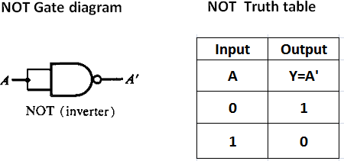
=> Y = (A)’

NAND gates as AND gate

A NAND produces complement of AND gate. So, if the output of a NAND gate is inverted, overall output will be that of an AND gate.
Y = ((A.B)’)’
=> Y = (A.B)

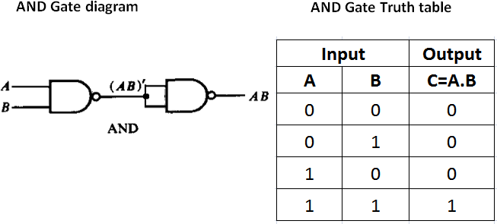

NAND gates as OR gate

From De-Morgan’s theorems: (A.B)’ = A’ + B’
=> (A’.B’)’ = A’’ + B’’ = A + B
So, give the inverted inputs to a NAND gate, obtain OR operation at output.

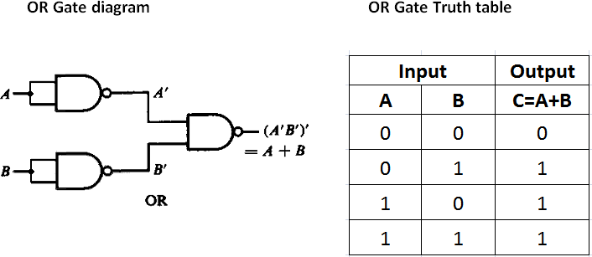

NAND gates as X-OR gate
The output of a two input X-OR gate is shown by: Y = A’B + AB’. This can be achieved with the logic diagram shown in the left side.

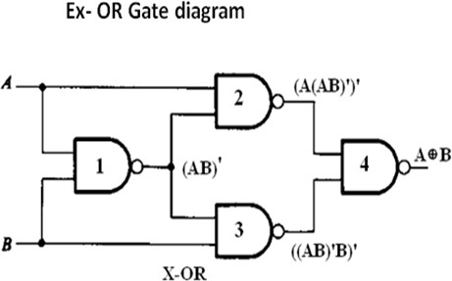
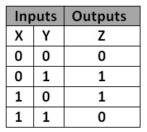

Gate No. | Inputs | Output
1 | A, B | (AB)’
2 | A, (AB)’ | (A (AB)’)’
3 | (AB)’, B | (B (AB)’)’
4 (A (AB)’)’, (B (AB)’)’ A’B + AB’
Now the output from gate no. 4 is the overall output of the configuration.
Y = ((A (AB)’)’ (B (AB)’)’)’
= (A(AB)’)’’ + (B(AB)’)’’
= (A(AB)’) + (B(AB)’)
= (A(A’ + B)’) + (B(A’ + B’))
= (AA’ + AB’) + (BA’ + BB’)
= ( 0 + AB’ + BA’ + 0 )
= AB’ + BA’
=> Y = AB’ + A’B

NAND gates as NOR gate

A NOR gate is an OR gate followed by NOT gate. So connect the output of OR gate to a NOT gate, overall output is that of a NOR gate.
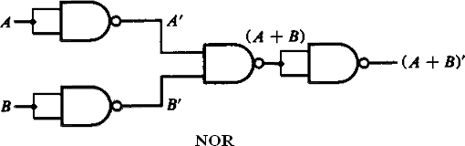
Y = (A + B)’

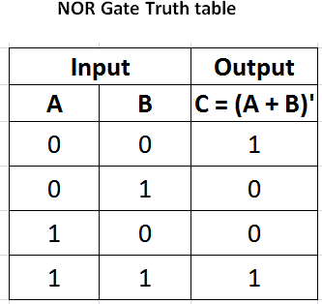
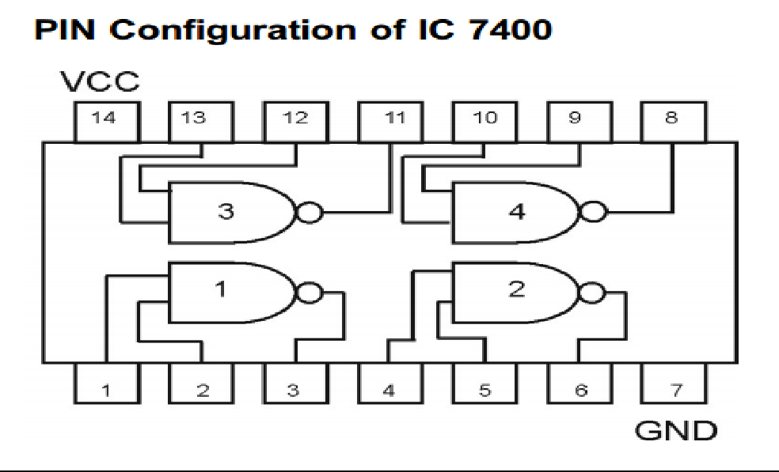

Procedure:
  - Connect the trainer kit to ac power supply.
  - Connect the NAND gates for any of the logic functions to be realized.
  - Connect the inputs of first stage to logic sources and output of the last gate to logic indicator.
  - Apply various input combinations and observe output for each one.
  - Verify the truth table for each input/ output combination.
  - Repeat the process for all logic functions.
  - Switch off the ac power supply.

RESULT:

AIM:- (b). To study and verify the all logic gates using UNIVERAL Gate NOR.

LEARNING OBJECTIVE:-
Identify NOR ICs and their specification.

COMPONENTS REQUIRED:-
Logic gates (IC) trainer kit. Connecting patch chords or wires. IC 7402

Theory:
NOR gate is actually a combination of two logic gates: OR gate followed by NOT gate. So its output is complement of the output of an OR gate. This gate can have minimum two inputs, output is always one. By using only NOR gates, we can realize all logic functions: AND, OR, NOT, X-OR, X-NOR, NAND. So this gate is also called universal gate.

(1). NOR gates as NOT gate
A NOT produces complement of the input. It can have only one input, tie the inputs of a NOR gate together. Now it will work as a NOT gate. Its output is
Y = (A+A)’
=> Y = (A)’
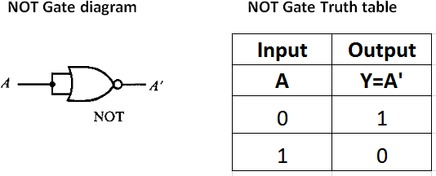

(2) NOR gates as OR gate
A NOR produces complement of OR gate. So, if the output of a NOR gate is inverted, overall output will be that of an OR gate.
Y = ((A+B)’)’
=> Y = (A+B)

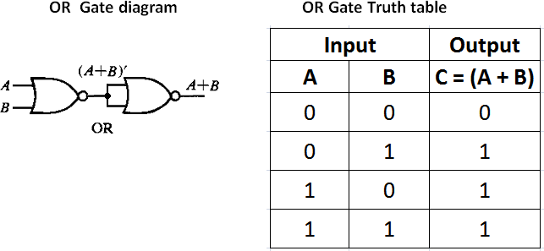

(3). NOR gates as AND gate
From De-Morgan’s theorems: (A+B)’ = A’B’
=> (A’+B’)’ = A’’B’’ = AB
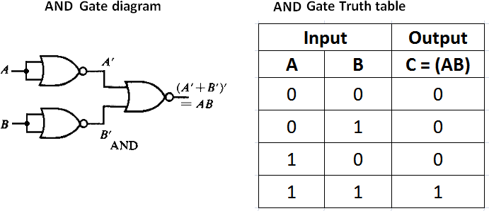
So, give the inverted inputs to a NOR gate, obtain AND operation at output.

(4). NOR gates as X-NOR gate
The output of a two input X-NOR gate is shown by: Y = AB + A’B’. This can be achieved with the logic diagram shown in the left side.
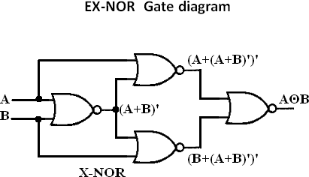

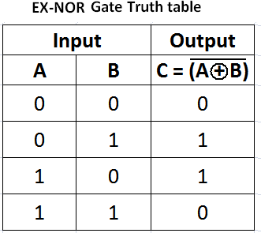

Gate No. | Inputs | Output
1 | A, B | (A + B)’
2 | A, (A + B)’ | (A + (A+B)’)’
3 | (A + B)’, B | (B + (A+B)’)’
4 | (A + (A + B)’)’, (B + (A+B)’)’ | AB + A’B’

Now the ouput from gate no. 4is the overall output of the configuration.
Y = ((A + (A+B)’)’ (B +( A+B)’)’)’
= (A+(A+B)’)’’.(B+(A+B)’)’’
= (A+(A+B)’).(B+(A+B)’)
= (A+A’B’).(B+A’B’)
= (A + A’).(A + B’).(B+A’)(B+B’)
= 1.(A+B’).(B+A’).1
= (A+B’).(B+A’)
= A.(B + A’) +B’.(B+A’)
= AB + AA’ +B’B+B’A’
= AB + 0 + 0 + B’A’
= AB + B’A’
=> Y = AB + A’B’

NOR gates as NAND gate

A NAND gate is an AND gate followed by NOT gate. So connect the output of AND gate to a NOT gate, overall output is that of a NAND gate.

Procedure:
  - Connect the trainer kit to ac power supply.
  - Connect the NOR gates for any of the logic functions to be realized.
  - Connect the inputs of first stage to logic sources and output of the last gate to logic indicator.
  - Apply various input combinations and observe output for each one.
  - Verify the truth table for each input/ output combination.
  - Repeat the process for all logic functions.
  - Switch off the ac power supply.
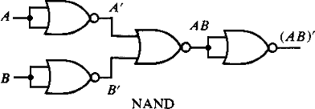
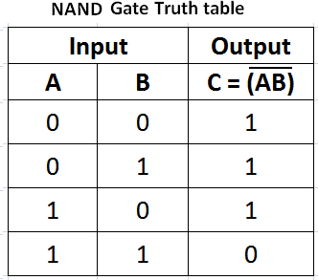
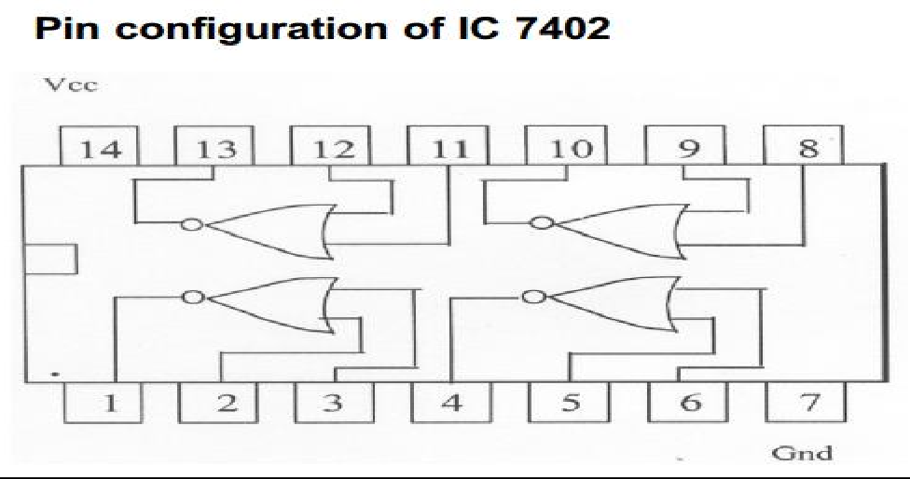
Precautions:

- All IC’s must be checked before start the experiment.
- All connections should made and tight.
- While making connections main voltage should be kept switch off.
- The circuit should be OFF before change the connection.

RESULT:

